Computer Architecture
John Carroll
902521946/jcc0044
Homework 6
Theme: Internal Memory
All questions are weighted equally. Show your work to receive credit.

- Consider a dynamic RAM that must be given a refresh cycle 66 times per millisecond. Each refresh operation requires 150 ns; a memory cycle requires 250 ns.
  - What percentage of the memory’s total operating time must be given to refreshes?
% refresh time = 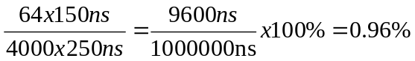

  - What is the maximum number of memory cycles in 1ms that can be used for reads/writes (refresh cycles are not part of memory accesses)?
in 1ms : refresh = 64 times, memory cycle = 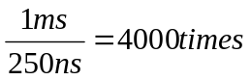

- Draw the diagram of a typical 16 Mb DRAM (4M X 4) and explain its action.
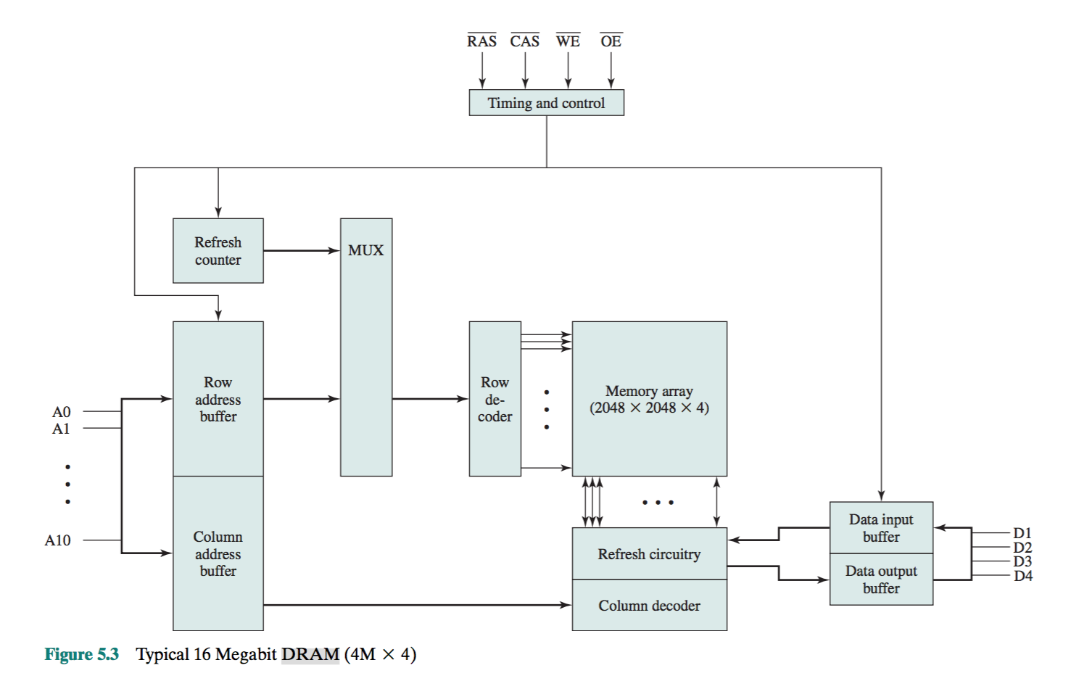
Figure 5.3 shows a typical organization of a 16-Mbit DRAM. In this case, 4 bits are read or written at a time. Logically, the memory array is organized as four square-arrays of 2048 by 2048 elements. Various physical arrangements are possible. In any case, the elements of the array are connected by both horizontal (row) and vertical (column) lines. Each horizontal line connects to the Select terminal of each cell in its row; each vertical line connects to the Data-In/Sense terminal of each cell in its column.
Address lines supply the address of the word to be selected. A total of log2 W lines are needed. In our example, 11 address lines are needed to select one of 2048 rows. These 11 lines are fed into a row decoder, which has 11 lines of input and 2048 lines for output. The logic of the decoder activates a single one of the 2048 outputs depending on the bit pattern on the 11 input lines (211 = 2048).
An additional 11 address lines select one of 2048 columns of 4 bits per column. Four data lines are used for the input and output of 4 bits to and from a data buffer. On input (write), the bit driver of each bit line is activated for a 1 or 0 according to the value of the corresponding data line. On output (read), the value of each bit line is passed through a sense amplifier and presented to the data lines. The row line selects which row of cells is used for reading or writing.
Because only 4 bits are read/written to this DRAM, there must be multiple DRAMs connected to the memory controller to read/write a word of data to the bus. Note that there are only 11 address lines (A0–A10), half the number you would expect for a 2048 * 2048 array. This is done to save on the number of pins. The 22 required address lines are passed through select logic external to the chip and multiplexed onto the 11 address lines. First, 11 address signals are passed to the chip to define the row address of the array, and then the other 11 address signals are presented for the column address. These signals are accompanied by row address select (RAS) and column address select (CAS) signals to provide timing to the chip. The write enable (WE) and output enable (OE) pins determine whether a write or read operation is performed. Two other pins, not shown in Figure 5.3, are
ground (Vss) and a voltage source (Vcc). As an aside, multiplexed addressing plus the use of square arrays result in a
quadrupling of memory size with each new generation of memory chips. One more pin devoted to addressing doubles the number of rows and columns, and so the size of the chip memory grows by a factor of 4.
Figure 5.3 also indicates the inclusion of refresh circuitry. All DRAMs require a refresh operation. A simple technique for refreshing is, in effect, to disable the DRAM chip while all data cells are refreshed. The refresh counter steps through all of the row’s values. For each row, the output lines from the refresh counter are sup- plied to the row decoder and the RAS line is activated. The data are read out and written back into the same location. This causes each cell in the row to be refreshed.

- Draw the diagram of an SRAM cell and explain its action.
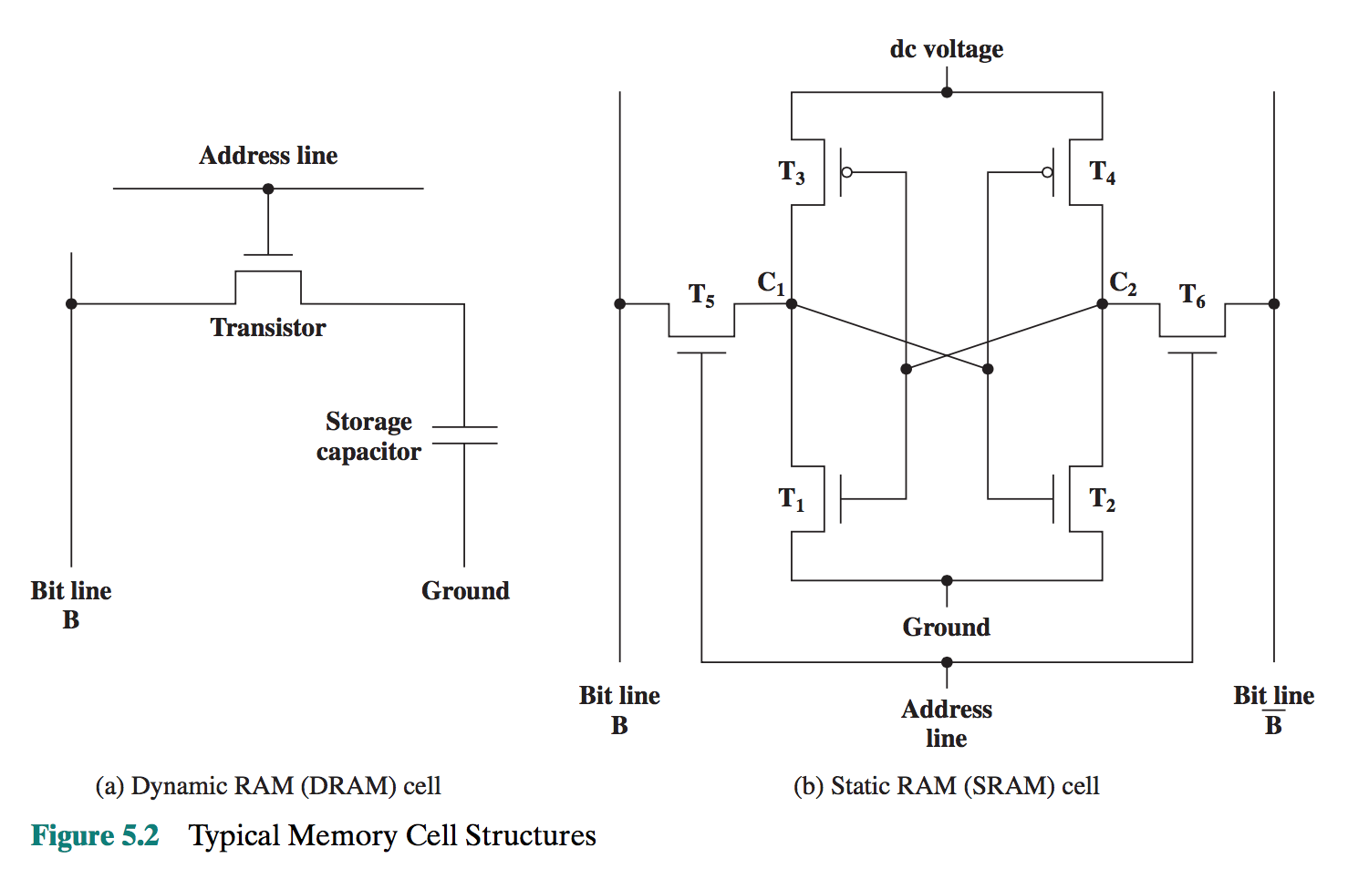In contrast, a static RAM (SRAM) is a digital device that uses the same logic elements used in the processor. In a SRAM, binary values are stored using traditional flip-flop logic-gate configurations. A static RAM will hold its data as long as power is supplied to it.
Figure 5.2b is a typical SRAM structure for an individual cell. Four transistors (T1, T2, T3, T4) are cross connected in an arrangement that produces a stable logic state. In logic state 1, point C1 is high and point C2 is low; in this state, T1 and T4 are off and T2 and T3 are on.1 In logic state 0, point C1 is low and point C2 is high; in this state, T1 and T4 are on and T2 and T3 are off. Both states are stable as long as the direct current (dc) voltage is applied. Unlike the DRAM, no refresh is needed to retain data.
As in the DRAM, the SRAM address line is used to open or close a switch. The address line controls two transistors (T5 and T6). When a signal is applied to this line, the two transistors are switched on, allowing a read or write operation. For a write operation, the desired bit value is applied to line B, while its complement is applied to line B. This forces the four transistors (T1, T2, T3, T4) into the proper state. For a read operation, the bit value is read from line B.

- What are the differences among EPROM, EEPROM? What is a DDR SDRAM?
Answer 1:
The optically erasable programmable read-only memory (EPROM) is read and written electrically, as with PROM. However, before a write operation, all the storage cells must be erased to the same initial state by exposure of the packaged chip to ultraviolet radiation. Erasure is performed by shining an intense ultraviolet light through a window that is designed into the memory chip. This erasure proc- ess can be performed repeatedly; each erasure can take as much as 20 minutes to perform. Thus, the EPROM can be altered multiple times and, like the ROM and PROM, holds its data virtually indefinitely. For comparable amounts of storage, the EPROM is more expensive than PROM, but it has the advantage of the multiple update capability.
A more attractive form of read-mostly memory is electrically erasable programmable read-only memory (EEPROM). This is a read-mostly memory that can be written into at any time without erasing prior contents; only the byte or bytes addressed are updated. The write operation takes considerably longer than the read operation, on the order of several hundred microseconds per byte. The EEPROM combines the advantage of non-volatility with the flexibility of being updatable in place, using ordinary bus control, address, and data lines. EEPROM is more expensive than EPROM and also is less dense, supporting fewer bits per chip.
Another form of semiconductor memory is flash memory (so named because of the speed with which it can be reprogrammed). First introduced in the mid-1980s, flash memory is intermediate between EPROM and EEPROM in both cost and functionality. Like EEPROM, flash memory uses an electrical erasing technology. An entire flash memory can be erased in one or a few seconds, which is much faster than EPROM. In addition, it is possible to erase just blocks of memory rather than an entire chip. Flash memory gets its name because the microchip is organized so that a section of memory cells are erased in a single action or “flash.” However, flash memory does not provide byte-level erasure. Like EPROM, flash memory uses only one transistor per bit, and so achieves the high density (compared with EEPROM) of EPROM.

Answer 2:
There is now an enhanced version of SDRAM, known as double data rate SDRAM (DDR-SDRAM) that overcomes the once-per-cycle limitation. DDR- SDRAM can send data to the processor twice per clock cycle.
SDRAM is limited by the fact that it can only send data to the processor once per bus clock cycle. A new version of SDRAM, referred to as double-data-rate SDRAM can send data twice per clock cycle, once on the rising edge of the clock pulse and once on the falling edge.

- How does an SDRAM differ from a DRAM? What is burst mode?
One of the most widely used forms of DRAM is the synchronous DRAM (SDRAM) [VOGL94]. Unlike the traditional DRAM, which is asynchronous, the SDRAM exchanges data with the processor synchronized to an external clock signal and running at the full speed of the processor/memory bus without imposing wait states. With synchronous access, the DRAM moves data in and out under control of the system clock. The processor or other master issues the instruction and address information, which is latched by the DRAM. The DRAM then responds after a set number of clock cycles. Meanwhile, the master can safely do other tasks while the SDRAM is processing the request.

The SDRAM employs a burst mode to eliminate the address setup time and row and column line pre-charge time after the first access. In burst mode, a series of data bits can be clocked out rapidly after the first bit has been accessed. This mode is useful when all the bits to be accessed are in sequence and in the same row of the array as the initial access. In addition, the SDRAM has a multiple-bank internal architecture that improves opportunities for on-chip parallelism. The mode register and associated control logic is another key feature differentiating SDRAMs from conventional DRAMs. It provides a mechanism to customize the SDRAM to suit specific system needs. The mode register specifies the burst length, which is the number of separate units of data synchronously fed onto the bus. The register also allows the programmer to adjust the latency between receipt of a read request and the beginning of data transfer.
The SDRAM performs best when it is transferring large blocks of data serially, such as for applications like word processing, spreadsheets, and multimedia.
In this case, the burst length is 4 and the latency is 2. The burst read command is initiated by having CS and CAS low while holding RAS and WE high at the rising edge of the clock. The address inputs determine the starting column address for the burst, and the mode register sets the type of burst (sequential or interleave) and the burst length (1, 2, 4, 8, full page). The delay from the start of the command to when the data from the first cell appears on the outputs is equal to the value of the CAS latency that is set in the mode register.

- What is a parity bit? What is Hamming code? Give examples.
The simplest of the error-correcting codes is the Hamming code devised by Richard Hamming at Bell Laboratories. Figure 5.8 uses Venn diagrams to illustrate the use of this code on 4-bit words (M = 4). With three intersecting circles, there are seven compartments. We assign the 4 data bits to the inner compartments (Figure5.8a). The remaining compartments are filled with what are called parity bits. Each parity bit is chosen so that the total number of 1s in its circle is even (Figure5.8b). Thus, because circle A includes three data 1s, the parity bit in that circle is set to 1. Now, if an error changes one of the data bits (Figure 5.8c), it is easily found. By checking the parity bits, discrepancies are found in circle A and circle C but not in circle B. Only one of the seven compartments is in A and C but not B. The error can therefore be corrected by changing that bit.
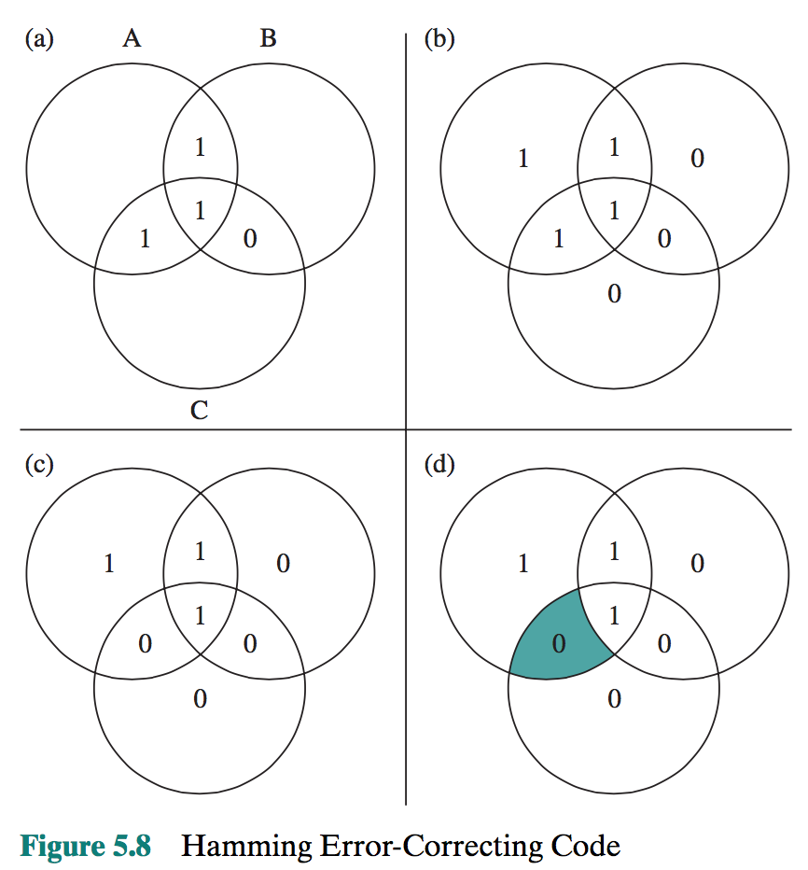

- What do you understand by interleaved memory?
Main memory is composed of a collection of DRAM memory chips. A number of chips can be grouped together to form a memory bank. It is possible to organize the memory banks in a way known as interleaved memory. Each bank is independently able to service a memory read or write request, so that a system with K banks can service K requests simultaneously, increasing memory read or write rates by a factor of K. If consecutive words of memory are stored in different banks, then the transfer of a block of memory is speeded up. Appendix E explores the topic of interleaved memory.

- How does the following work: flash memory, STT-RAM, PCRAM, ReRAM?

Flash memory: Another form of semiconductor memory is flash memory (so named because of the speed with which it can be reprogrammed). First introduced in the mid-1980s, flash memory is intermediate between EPROM and EEPROM in both cost and functionality. Like EEPROM, flash memory uses an electrical erasing technology. An entire flash memory can be erased in one or a few seconds, which is much faster than EPROM. In addition, it is possible to erase just blocks of memory rather than an entire chip. Flash memory gets its name because the microchip is organized so that a section of memory cells are erased in a single action or “flash.” However, flash memory does not provide byte-level erasure. Like EPROM, flash memory uses only one transistor per bit, and so achieves the high density (compared with EEPROM) of EPROM.

STT-RAM: Spin-transfer torque can be used to flip the active elements in magnetic random-access memory. Spin-transfer torque magnetic random-access memory (STT-RAM or STT-MRAM) has the advantages of lower power consumption and better scalability over conventional magnetoresistive random-access memory (MRAM) which uses magnetic fields to flip the active elements. Spin-transfer torque technology has the potential to make possible MRAM devices combining low current requirements and reduced cost; however, the amount of current needed to reorient the magnetization is at present too high for most commercial applications, and the reduction of this current density alone is the basis for current academic research in spin electronics.

PCRAM: Phase-change memory (also known as PCM, PCME, PRAM, PCRAM, Ovonic Unified Memory, Chalcogenide RAM and C-RAM) is a type of non-volatile random-access memory. PRAMs exploit the unique behaviour of chalcogenide glass. In the older generation of PCM heat produced by the passage of an electric current through a heating element generally made of TiN would be used to either quickly heat and quench the glass, making it amorphous, or to hold it in its crystallization temperature range for some time, thereby switching it to a crystalline state. PCM also has the ability to achieve a number of distinct intermediary states, thereby having the ability to hold multiple bits in a single cell, but the difficulties in programming cells in this way has prevented these capabilities from being implemented in other technologies (most notably flash memory) with the same capability. Newer PCM technology has been trending in two different directions. One group have been directing a lot of research towards attempting to find viable material alternatives to Ge₂Sb₂Te₅ (GST), with mixed success. Another have developed the use of a GeTe - Sb₂Te₃ superlattice to achieve non-thermal phase changes by simply changing the co-ordination state of the Germanium atoms with a laser pulse. This new Interfacial Phase Change Memory (IPCM) has had many successes and continues to be the site of much active research

ReRAM: Resistive random-access memory (RRAM or ReRAM) is a type of non-volatile (NV) random-access (RAM) computer memory that works by changing the resistance across a dielectric solid-state material often referred to as a memristor. This technology bears some similarities to CBRAM and phase-change memory (PCM).
CBRAM involves one electrode providing ions that dissolve readily in an electrolyte material, while PCM involves generating sufficient Joule heating to effect amorphous-to-crystalline or crystalline-to-amorphous phase changes. On the other hand, RRAM involves generating defects in a thin oxide layer, known as oxygen vacancies (oxide bond locations where the oxygen has been removed), which can subsequently charge and drift under an electric field. The motion of oxygen ions and vacancies in the oxide would be analogous to the motion of electrons and holes in a semiconductor.
RRAM is currently under development by a number of companies, some of which have filed patent applications claiming various implementations of this technology. RRAM has entered commercialization on an initially limited KB-capacity scale.
Although commonly anticipated as a replacement technology for flash memory, the cost benefit and performance benefit of RRAM have not been obvious enough to most companies to proceed with the replacement. A broad range of materials apparently can potentially be used for RRAM. However, the recent discovery that the popular high-κ gate dielectric HfO₂ can be used as a low-voltage RRAM has greatly encouraged others to investigate other possibilities.

